EXP NO 4: Create a simple cloud software application for Car Booking Reservation
System using any Cloud Service Provider to demonstrate SaaS.

AIM: To Create a simple cloud software application for Car Booking Reservation
System using any Cloud Service Provider to demonstrate SaaS.

PROCEDURE:

Step1: go to zoho.com
Step 2: login to the zoho.com
Step 3: Create an application and open it.
Step 4: give a name as car booking to the application and add a form in the name Booking Details application.
Step 5: Add the required fields like fuel type, milage, capacity, ..etc.
Step 6:Click done and run the application.

OUTPUT:

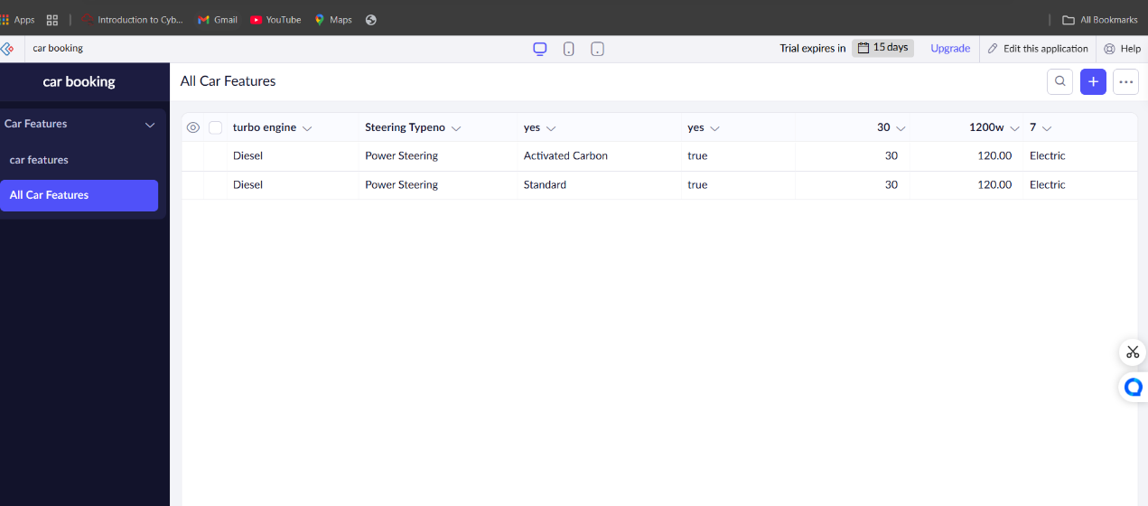

RESULT:

We have sucessfully created a simple cloud software application for flight reservation system using any cloud service provider to demonstrate saas.

